* Navigate to <https://console.cloud.google.com/marketplace/product/google/container.googleapis.com> click the blue button **ENABLE  
  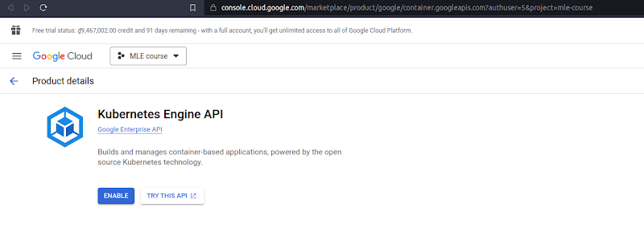**
* After waiting for a while, you will be navigated to this page.  
  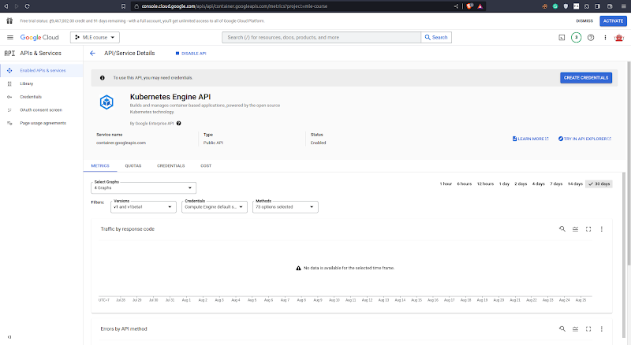
* Access <https://console.cloud.google.com/kubernetes>. You will see the following page:  
  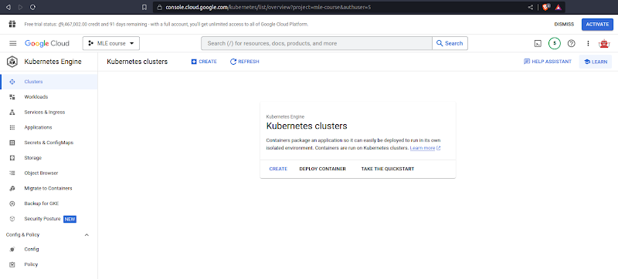
* Hit the button **CREATE**, and hit **LET’S GET STARTED  
  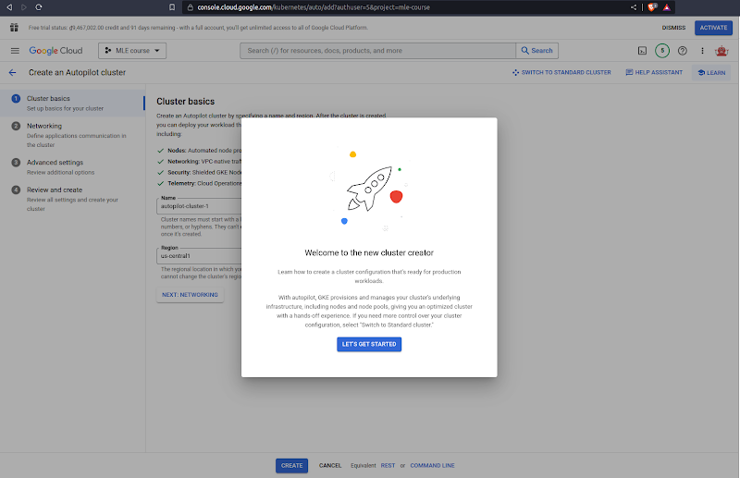**
* Click the **CREATE** button, and wait for **about 10 minutes  
  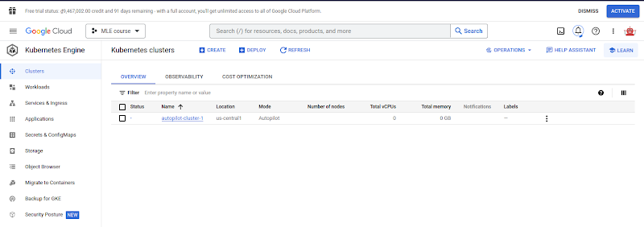**
* Now, you can see the cluster has been provisioned successfully!  
  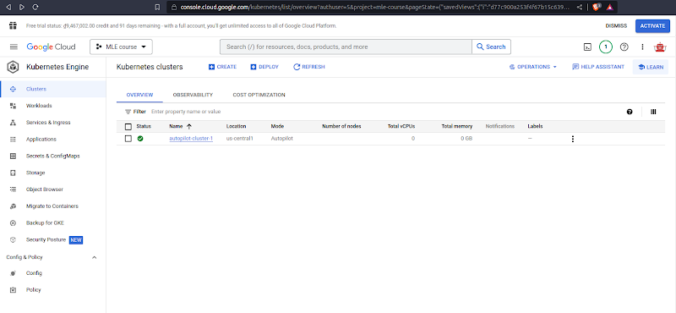
* Click on the cluster **autopilot-cluster-1** and select **CONNECT  
  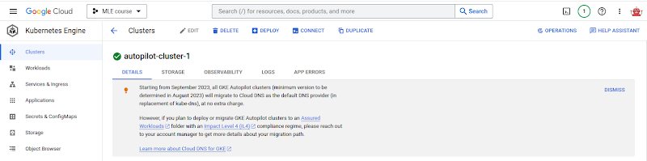**
* You will see the popup **Connect to the cluster** as follows  
  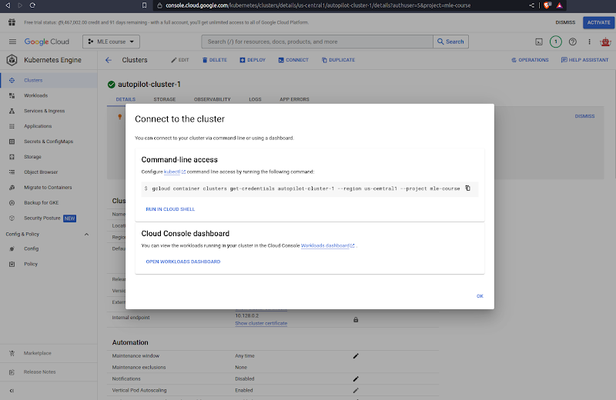
* Copy the line `gcloud container …` into your local terminal as follows  
  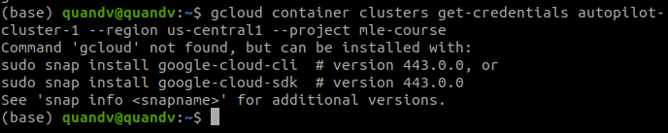
* Well, we haven’t installed gcloud CLI, let’s do it now by following this document  
  <https://cloud.google.com/sdk/docs/install#deb>.
* After that, initialize the gcloud CLI by typing `gcloud init`, then type Y  
  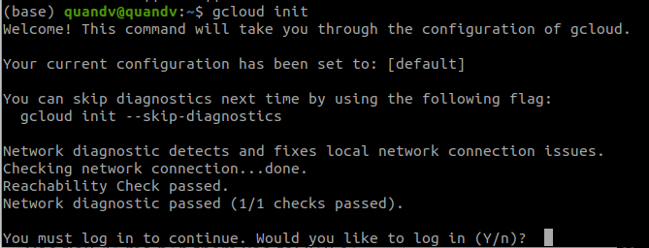
* A pop-up to select your Google account will appear, select the one you used to register GCP, and click the button **Allow  
  **
* Now, go back to your terminal, in which you typed `gcloud init`, type **1,** andEnter  
  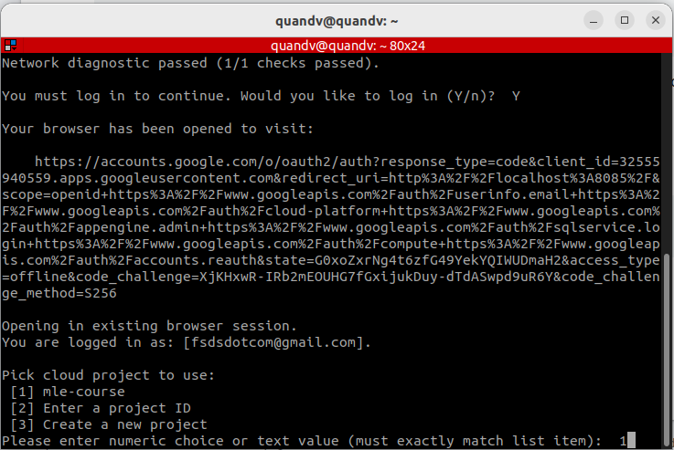

**,**  type Y, and type 8, then Enter.  
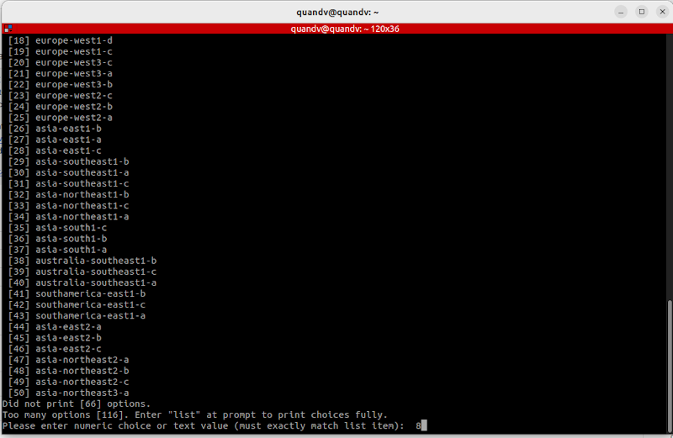

* Now, rerun the command **`gcloud container …`** in step 8  
  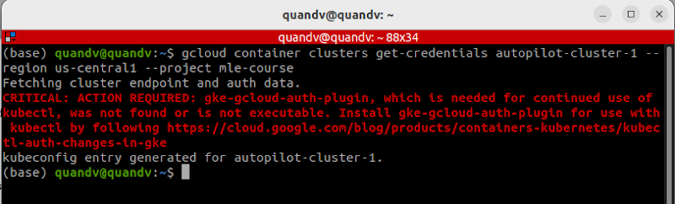
* Now, we need to install gke-cloud-auth-plugin

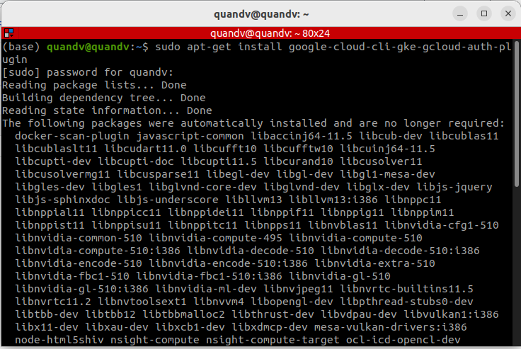

* And...rerun the command **`gcloud container …`** in step 8  
  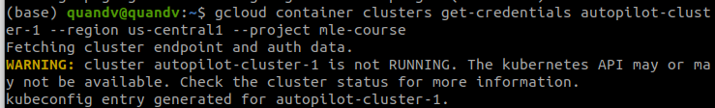

We can see the line `kubeconfig entry generated for autopilot-cluster-1`, that’s good!

* Now, type kubectx in your terminal and select your cluster  
  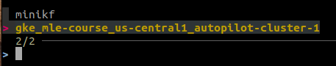  
  After that, you will see the following result:  
  
* Try getting pods  
  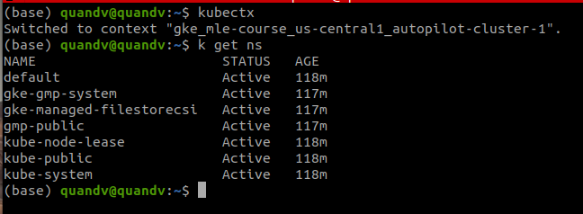
* OK for now. If you want to delete the cluster, navigate back to the tab **Clusters**, check the cluster box, and hit **DELETE  
  